**Magha Puja Day**

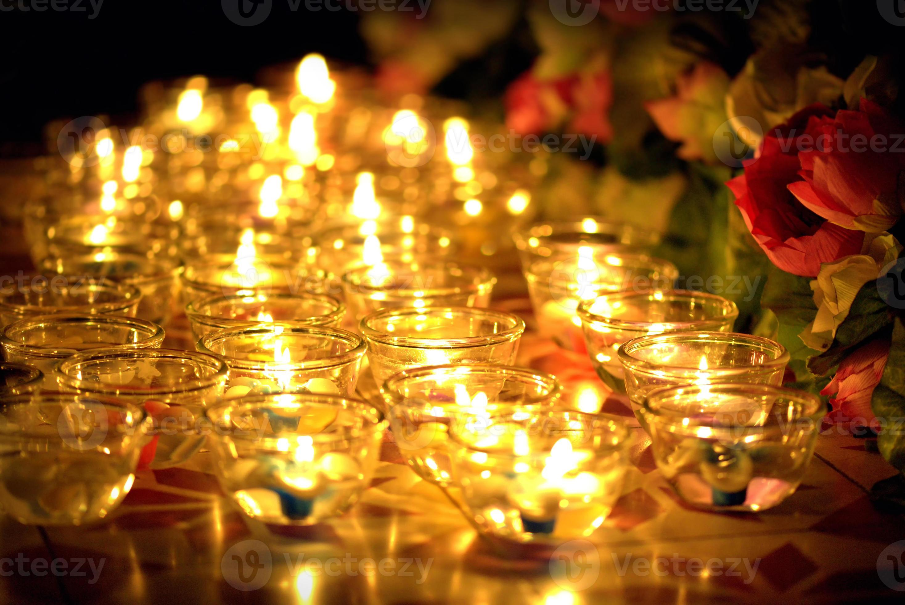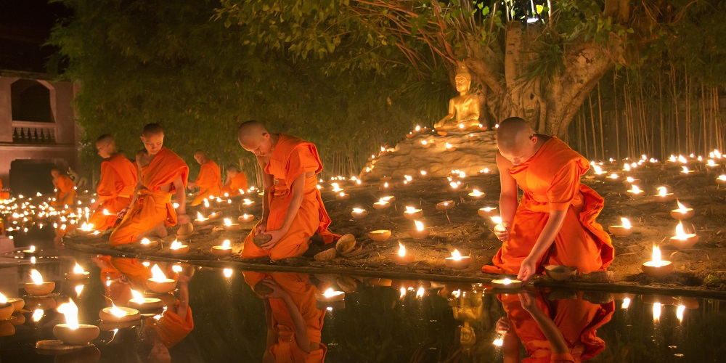This Buddhist holiday celebrates a moment about 2,500 years ago when 1,250 enlightened Buddhist monks who had all been ordained by the Buddha came to see the Buddha without being summoned on the night of the full moon of the third lunar month. At a second, similar gathering 45 years later, also held on the first full moon of the third month, the Buddha announced that he intended to die in three months’ time.

This announcement marks an important moment in Buddhist history. It is traditional to use this day to honor the Three Jewels of Buddhism: the Buddha (his enlightenment), the Sangha (the community of Buddhists around the world) and the Dharma (the teachings of the Buddha).